Canoe/Kayak Races
Registration begins at 8:00 AM at the
Bald Eagle State Park beach
Races begin at 9:00 AM
For the Serious Paddler
A ~8 Mile Race that begins and ends at
the Bald Eagle State Park beach.
Cost: $25.00 per boat

Youth Race/Splash game ~2 miles @ 9 am
$5 per racer

Recreational Canoe/Kayak Races
Registration Begins at 10:30 AM at the Bald Eagle State Park beach
Race begins at 11:30 AM
Are you a beginner? Are you just in it for fun?
A ~ 4 Mile Race that begins and ends at the Bald Eagle State Park beach.
Cost: $25.00 per boat

Note: No additional fee for adult if raced in a prior class and racing in Adult junior/youth class

Adults enter both race and rec divisions for $30

Any racer in the Recreational Division is entered into Bricktown Gamble poker run! Collect 5 tokens on the course and exchange for a hand of cards at the finish. Best hand wins a kayak.

Need a kayak or canoe?
Reserve your boats now @

Tussey Mountain Outfitters: (814)355-5690
Country Ski & Sport: (570) 368-1718

Camping Reservations: 888-PA-PARKS or http://www.pa.reserveworld.com/
Don’t forget about the awesome Nature Inn
http://natureinnatbaldeagle.com/

Deadline to PreRegister is
July 7th, 2014
Register form online at
www.beechcreekwatershed.org

First 50 competitors recieve a
2014 Bricktown Challenge
T-Shirt

To qualify for pre-pricing, your entry and payment must be received by July 7, 2014. LATE FEE is an additional $5.00

Make your checks payable to:
Beech Creek Watershed Association

Mail your check and entry form to:

Beech Creek Watershed Association
P.O. Box 286
Mill Hall, Pa 17751

For additional information:
Visit www.beechcreekwatershed.org
Or call Ashley Lister at
(610) 858-2097
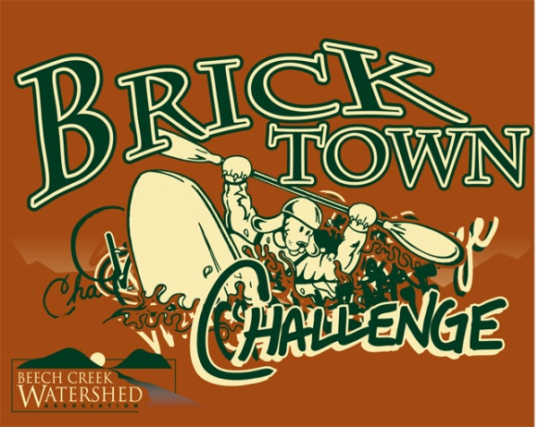

P.A.C.K. Championship &
6th Annual
Bricktown Challenge
presented by
Beech Creek Watershed Association and
Bald Eagle State Park
To Benefit the Bricktown Trail
The Sixth Annual Bricktown Challenge is an amateur canoe and kayak race open to all skill levels ages 5 and up.

Saturday July 12, 2014
Rain or Shine

Featuring Three Divisions and a Poker Run
Youth ~2 mi, Recreational ~4 mi
Canoe/Kayak Races- ~8 mi
Adult Rec Classes (~4 miles), Start Time 11:30 a.m.
⇨K1 Recreation* (Circle One) (Mens) (Womens)
⇨K1 Sea Kayak/Touring/ Down River
(Circle One) (Mens) (Womens)
⇨K1 Racing /Surf Ski (Circle One) (Mens) (Womens)
⇨K2 Kayak (Circle One) (Mens) (Womens) (Mixed)
⇨C2 Recreation /Standard Canoe (Circle One)
(Womens) (Mixed) (Mens)
⇨C2 Senior Century – age of paddlers must total >100
⇨C2 Cruiser 4x32 or Pro 3x27 (Circle One)
(Womens) (Mens) (Mixed)
⇨C1 Recreation/Standard Canoe (Circle One)
(Womens) (Mens)
⇨C1 Cruiser Canoe (Circle One)
(Womens) (Mens)
⇨C4 Open (Circle One)
(Womens) (Mens) (Mixed)
⇨S1 Stand Up Paddle Board Open (Circle One)
(Womens) (Mens)

Adult/Junior/Youth Rec Classes (~4 miles), ST 11:30 a.m.
⇨C2 Recreation/Standard Canoe* (Adult/Jr 5-11) (Adult/Youth, 12-17)
⇨C2 Cruiser 4x32 or Pro 3x27 (Adult/Jr 5-11) (Adult/Youth, 12-17)
⇨ K2 Kayak (Adult/Jr 5-11) (Adult/Youth, 12-17)
⇨ C4 Open (Circle One)
(Womens) (Mens) (Mixed)

Bob Mann Memorial Class (~4 miles), ST 11:30 a.m.
⇨ Canoe or Kayak
Fire Co. Name ________________________________

Your choice of canoe or kayak one or more paddlers – All proceeds from this class will be donated to the Howard Fire Company – Must be a volunteer firefighter or EMT to enter this class – Competition between Fire Companies is highly encouraged!

Junior/Youth Classes (~2 miles), Start Time 9:00 a.m.
(Junior ages, 5-11) (Youth ages 12-17)
⇨K1 Recreation* (boat <14 ft) (Circle One)(Junior)(Youth)
⇨K1 Sea Kayak/Touring / Down River (Circle One) (Junior) (Youth)
⇨K1 Kayak Racing (Circle One) (Junior) (Youth)
⇨C1 Recreation/Standard Canoe (Circle One) (Junior) (Youth)
⇨C1 Cruiser Canoe (Circle One) (Junior) (Youth)
⇨C2 Recreation/Standard Canoe (Circle One) (Junior) (Youth)
⇨C2 Cruiser 4x32 or Pro 3x27 (Circle One) (Junior) (Youth)
Adult Race Classes (~8 miles), Start Time 9:00 a.m.
(Mens < 40,/Masters 40-49/ Senior 50-59 /Veteran > 60)
⇨K1 Recreation* (Circle One) (Mens) (Womens)
⇨K1 Sea Kayak/Touring (Circle One) (Mens) (Womens)
⇨K1 Down River (Circle One) (Mens) (Womens)
⇨K1 Racing (Circle One) (Mens) (Womens)
⇨K1 Surf Ski (Circle One) (Mens) (Womens)
⇨K2 Kayak (Circle One) (Mens) (Womens) (Mixed)
⇨C2 Recreation Canoe (Circle One)
(Womens) (Mixed) (Mens)
⇨C2 Standard (Stock) Canoe (Circle One)
(Wood, Fiberglass, Carbon Fiber or Kevlar)
(Womens) (Mixed) (Mens)
⇨C2 Cruiser 4x32 or Pro 3x27 (Circle One)
(Womens) (Mens) (Master) (Senior) (Veteran) (Mixed)
⇨C1 Recreation Canoe (Circle One)
(Womens) (Mens) (Master) (Senior) (Veteran)
⇨C1 Cruiser Canoe (Circle One)
(Womens) (Mens) (Master) (Senior) (Veteran)
⇨C1 Standard (Stock) Canoe (Circle One)
(Womens) (Mens) (Master) (Senior) (Veteran)
⇨C4 Open (Circle One)
(Womens) (Mens) (Mixed)
⇨S1 Stand Up Paddle Board Open (Circle One)
(Womens) (Mens)

T- Shirt Size (circle one) S M L XL
2014 Bricktown Challenge Canoe & Kayak Official Registration Form
Rain or Shine Saturday July 12, 2014 www.beechcreekwatershed.org

Name______________________ Age_____

Address____________________ Sex_____

City ____________ State ____ Zip _______

Phone ______________ Email__________
Entry #

Assigned by
Race Director

T- Shirt Size (circle one) S M L XL

2nd Participant (When Applicable)

Name______________________ Age_____

Address____________________ Sex_____

City ____________ State ____ Zip _______

Phone ______________ Email__________

Entry #
Assigned by
Race Director
Note : K1 recreation kayaks not to exceed 14 feet in length.
All racers (i.e., both tandem partners) must read and sign USCA waiver at registration on the day of the event

